**Creating AWS account :-**

Step1 :- First search AWS in google search bar and open aws webpage and in the home page click “Create an AWS account”.

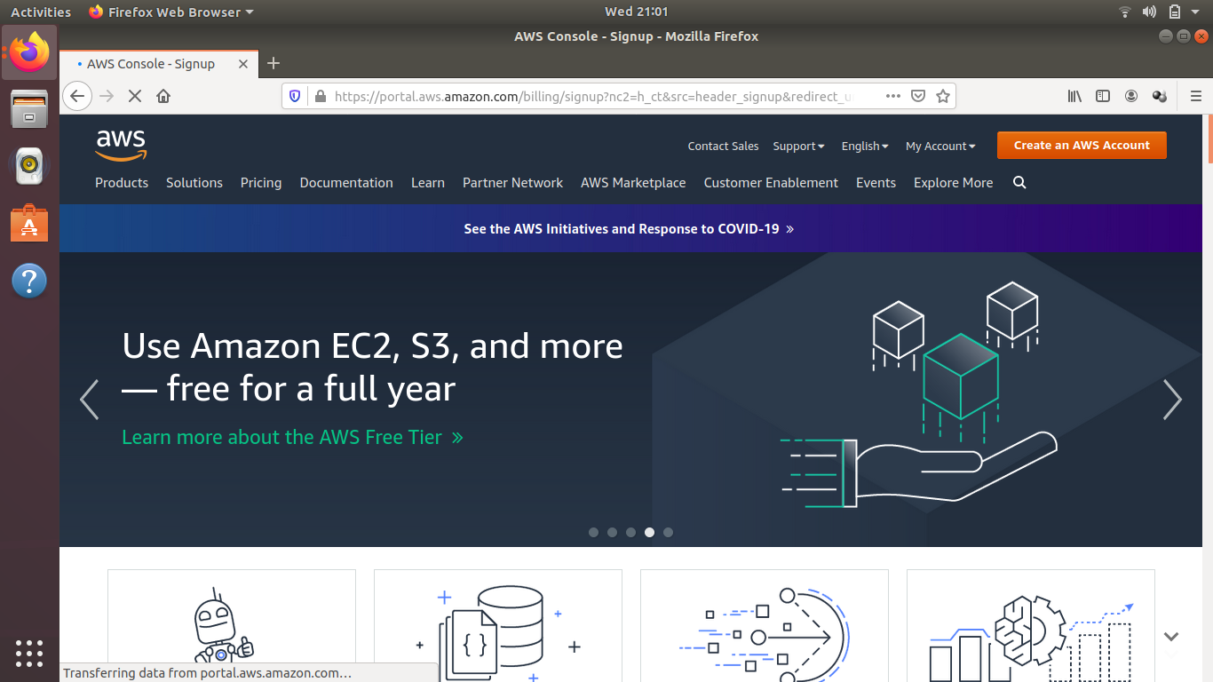

Step2 :- Enter the Email and password .

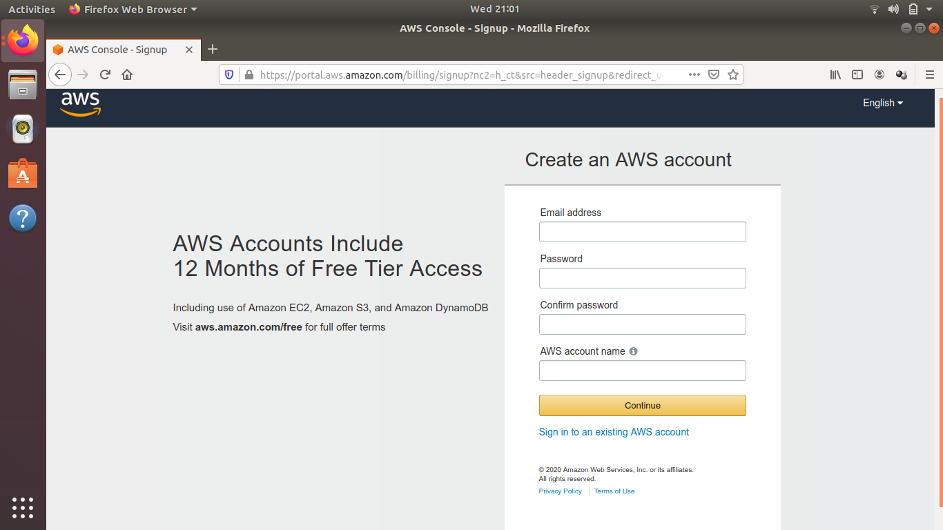

Step3 :- In this one need to provide address,state,pin etc related information and choose the option whether it is for personal or professional use.

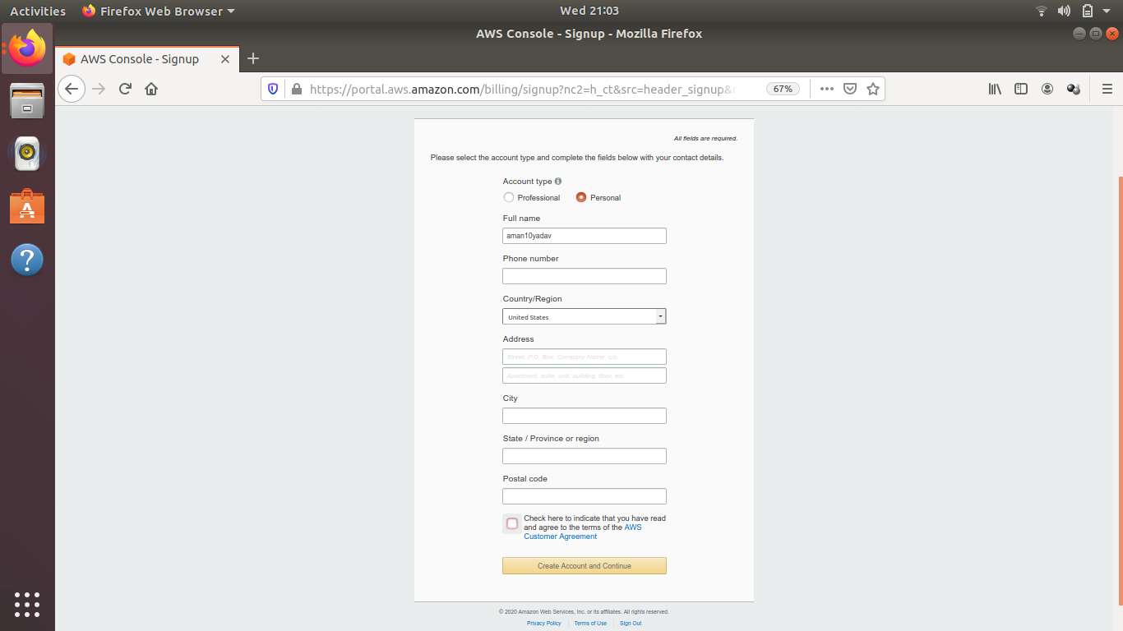

Step4 :- Now provide the card details as it is free for one year then after it will charge.

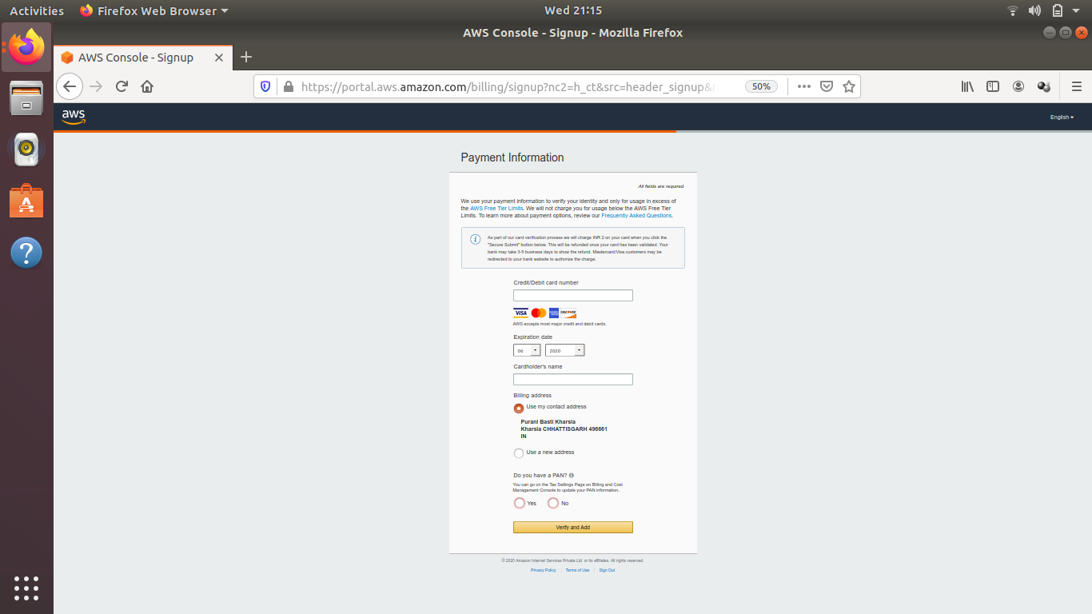

Step5 :- After this provide the identity by confirming mobile number and country name.

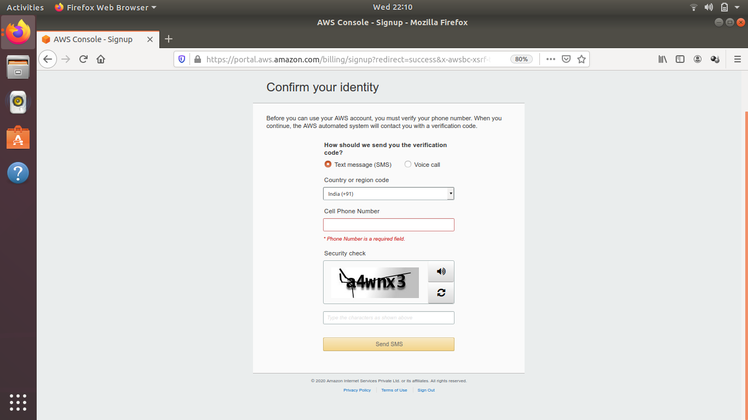

Step6 :- Now according to requirement plan must be selected.

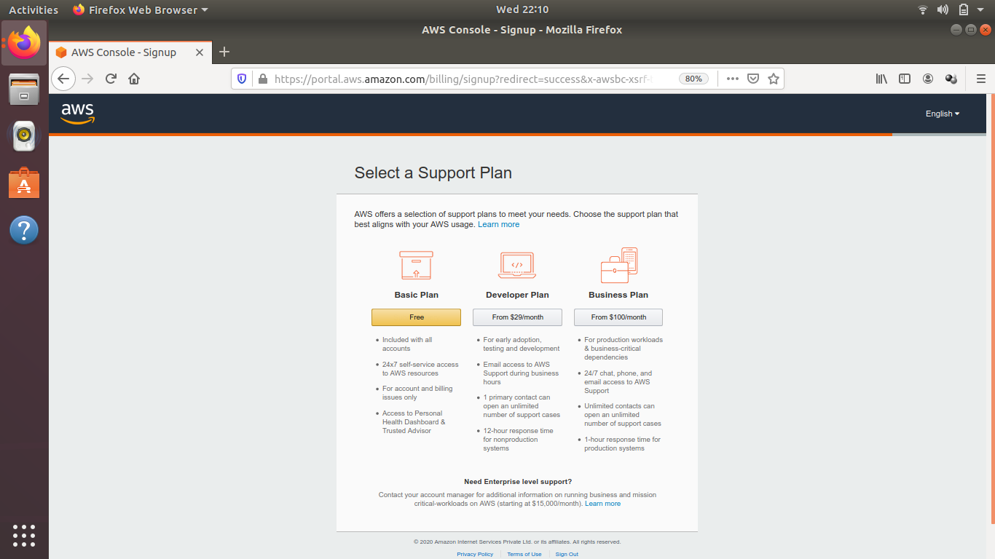

Step7 :- After successfully registering,one can sign in and use the aws services happily.

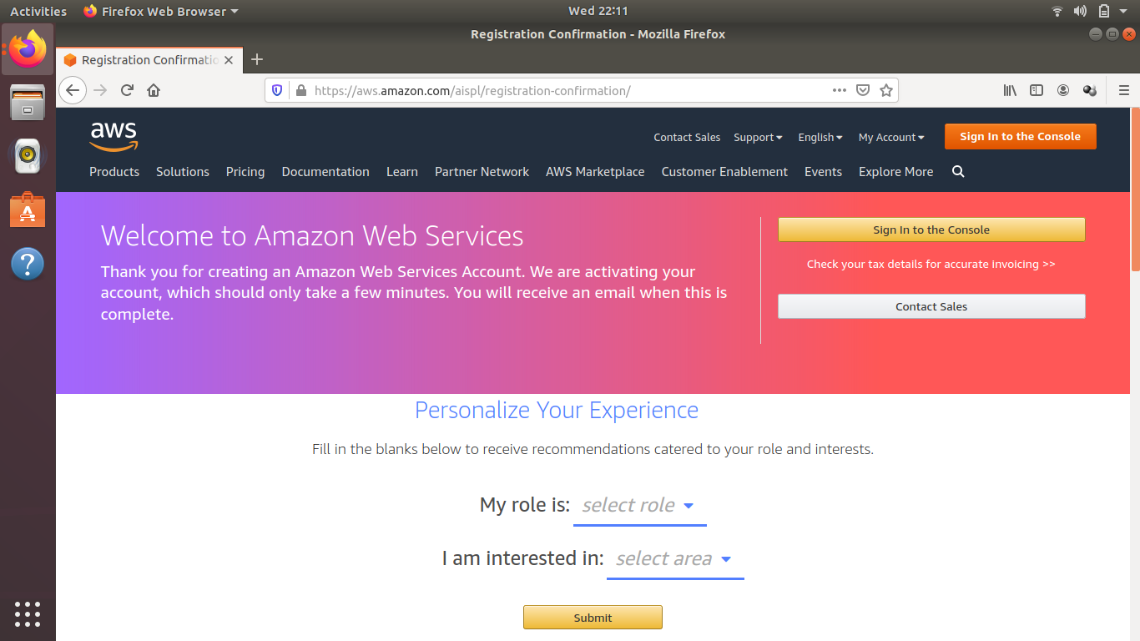

**Creating EC2 Instances**

Step1 :- First checkout you have logged in.

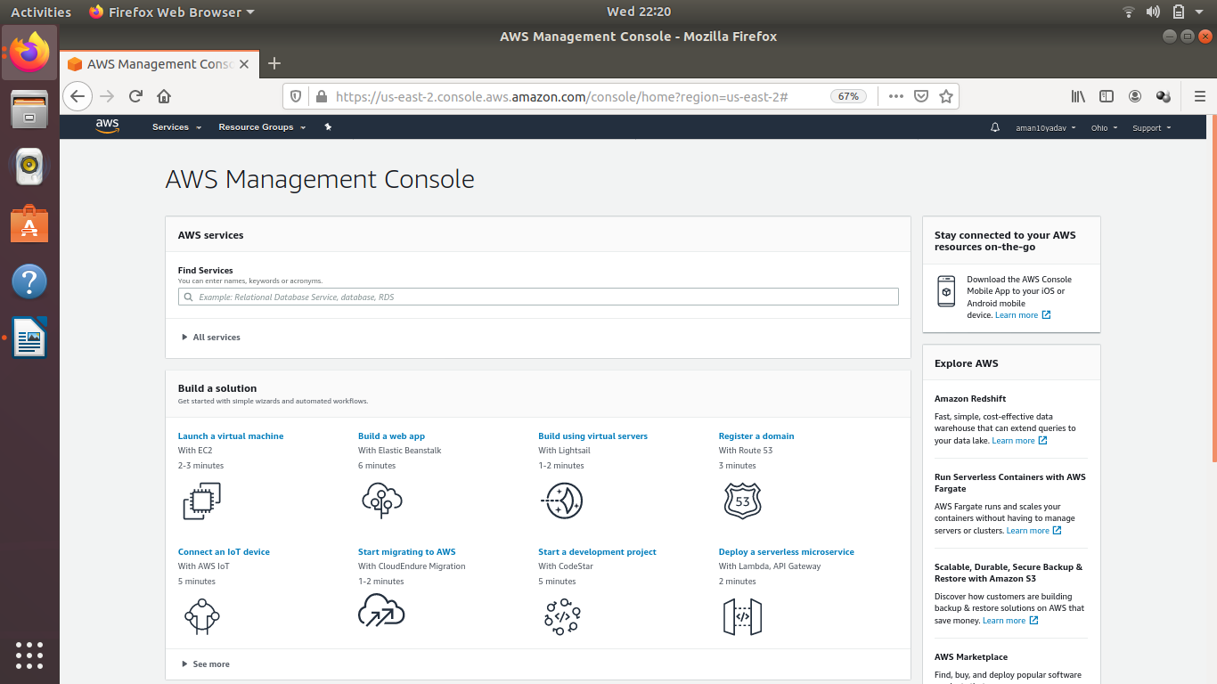

Step2 :- Click on service menu.Then on compute section click on EC2.

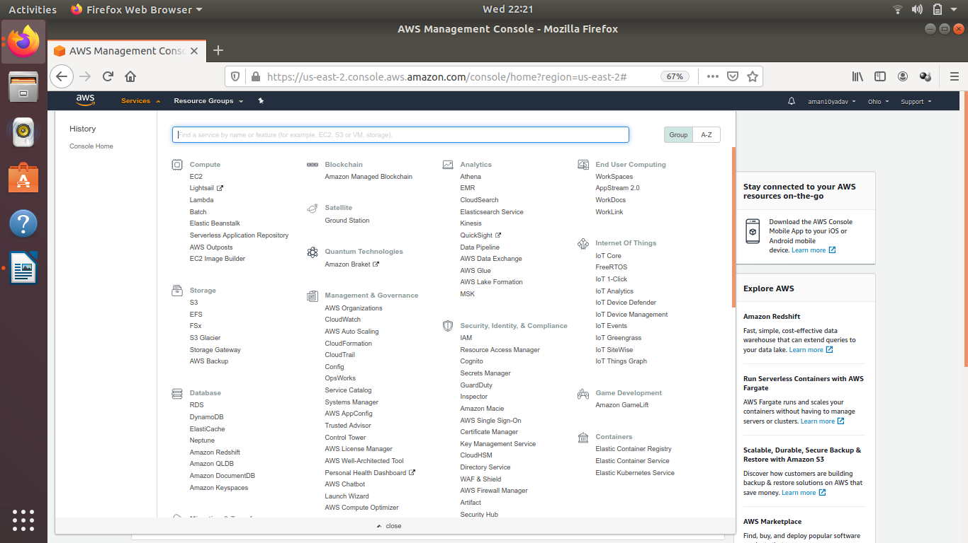

Step3 :- Click on Launch Instance.

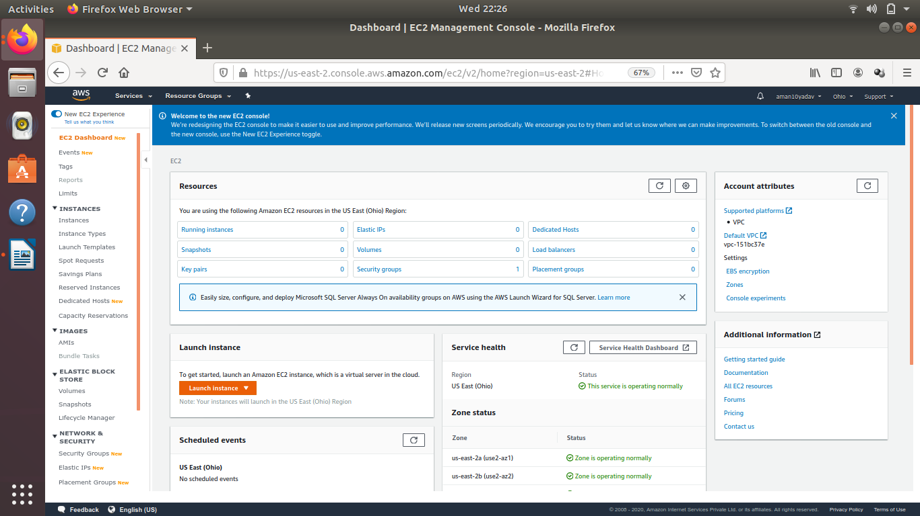

Step4 :- Click select button in option “**Ubuntu Server 18.04 LTS (HVM), SSD Volume Type** - ami-07c1207a9d40bc3bd (64-bit x86) / ami-0a5ee0336de62011b (64-bit Arm)”.

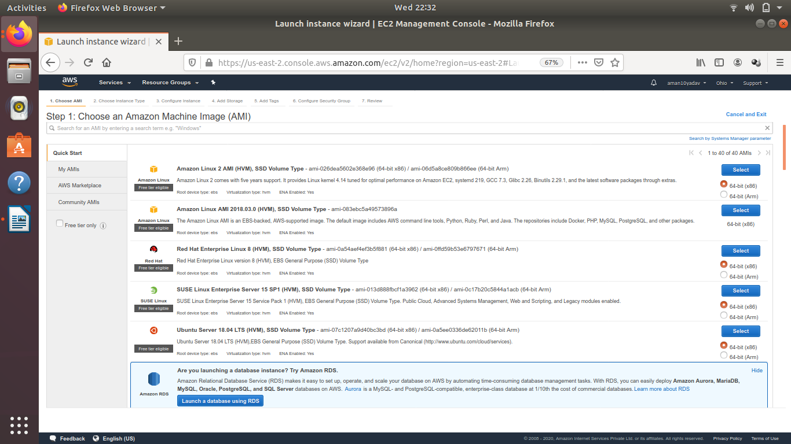

Step5 :- Check the option which consist of free tier eligible written in Type and then click on next Configure Instance Details.

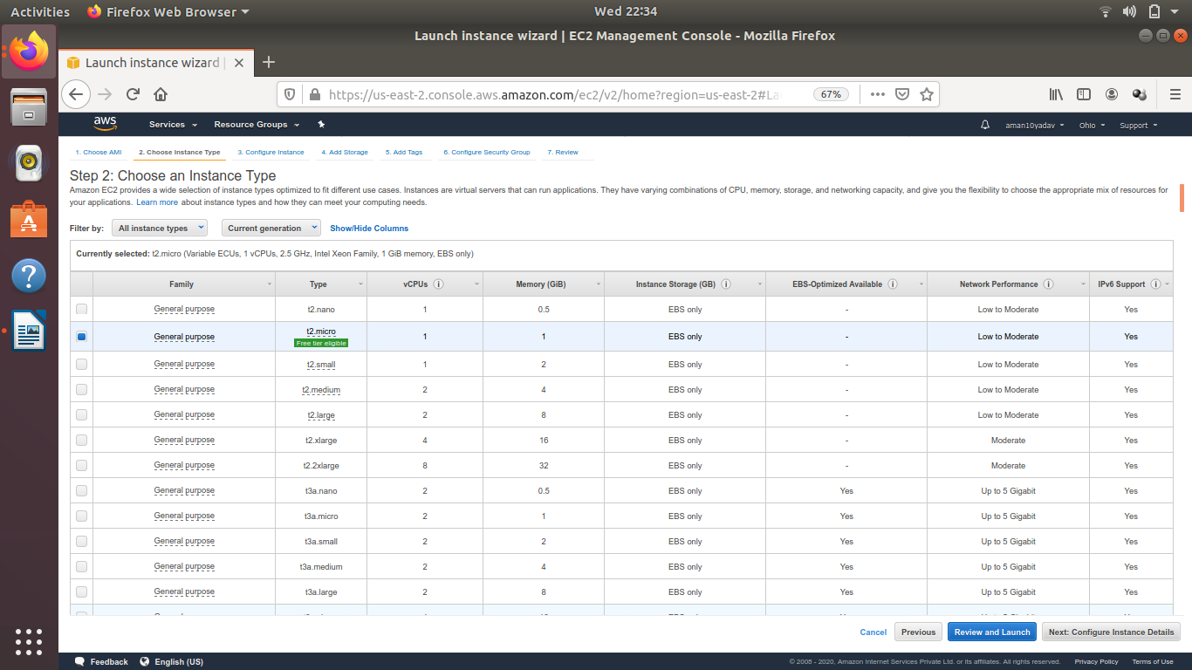

Step6 :- Select or set options as given below in the image and then click on “Next: Add Storage”.

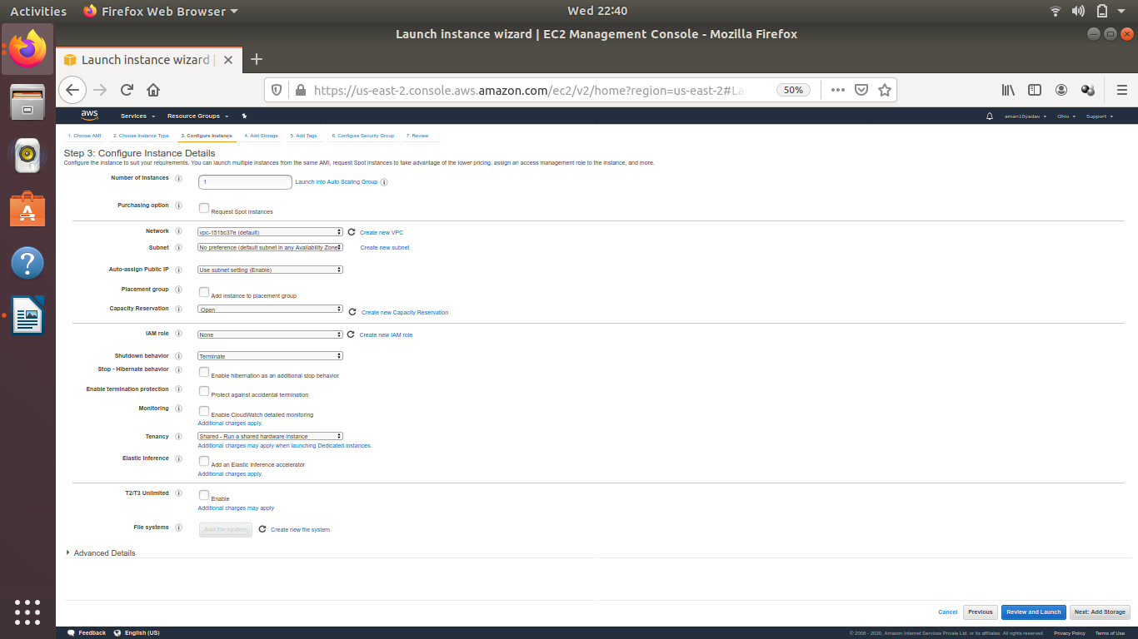

Step7 :- If require then increase the size or else click on “Next: Add Tags”.

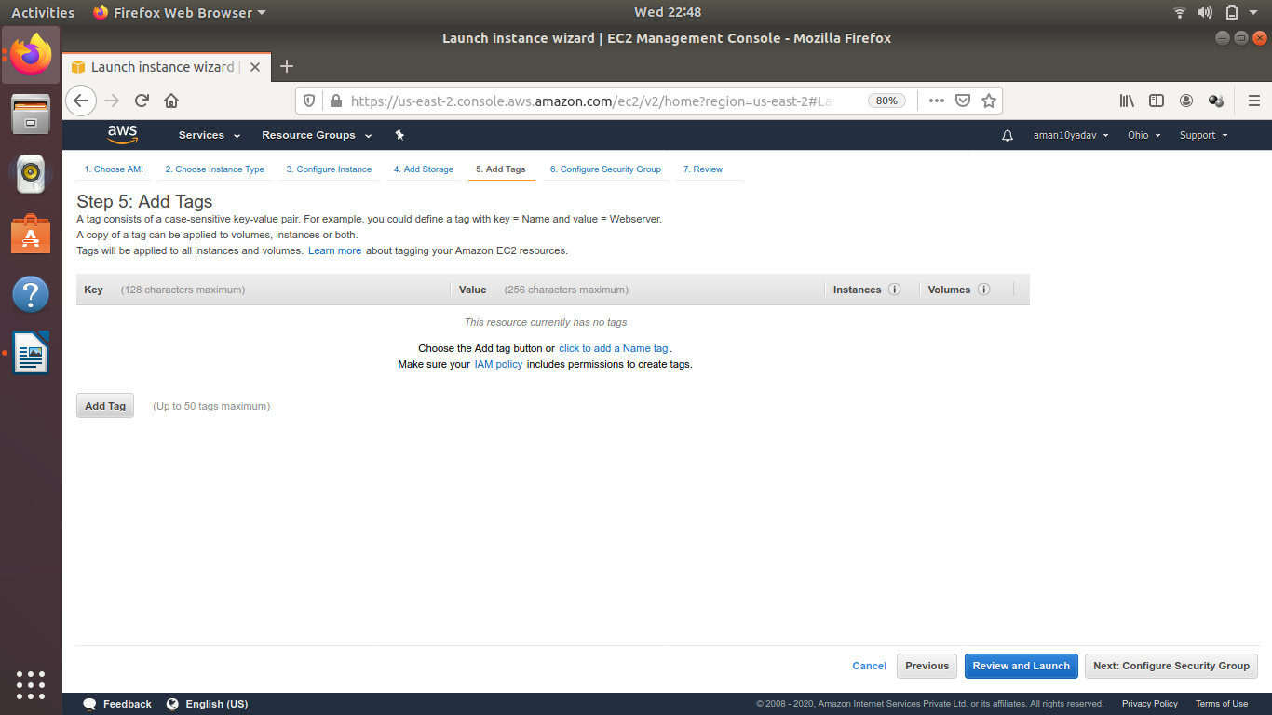

Step8 :- Now click on Add Tag and then provide key and value name.After that click on Review and Launch.

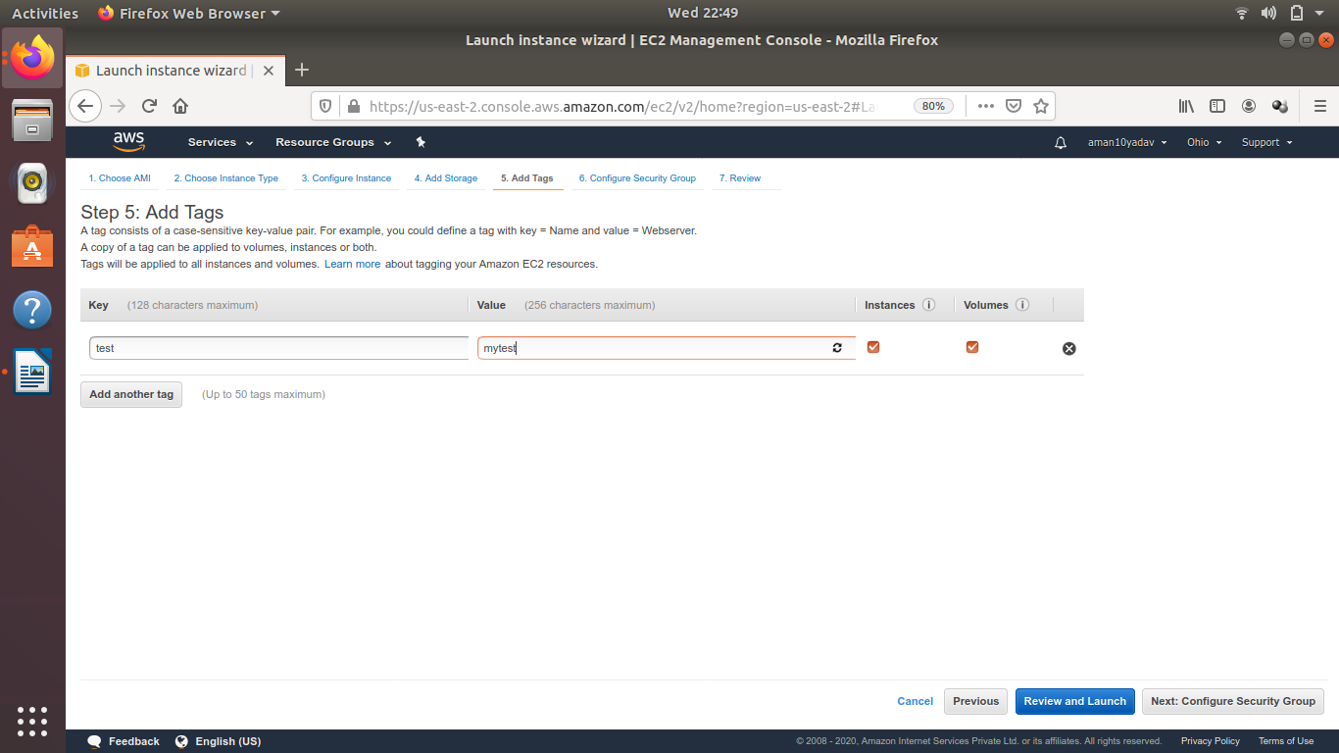

Step9 :- Click on Launch.

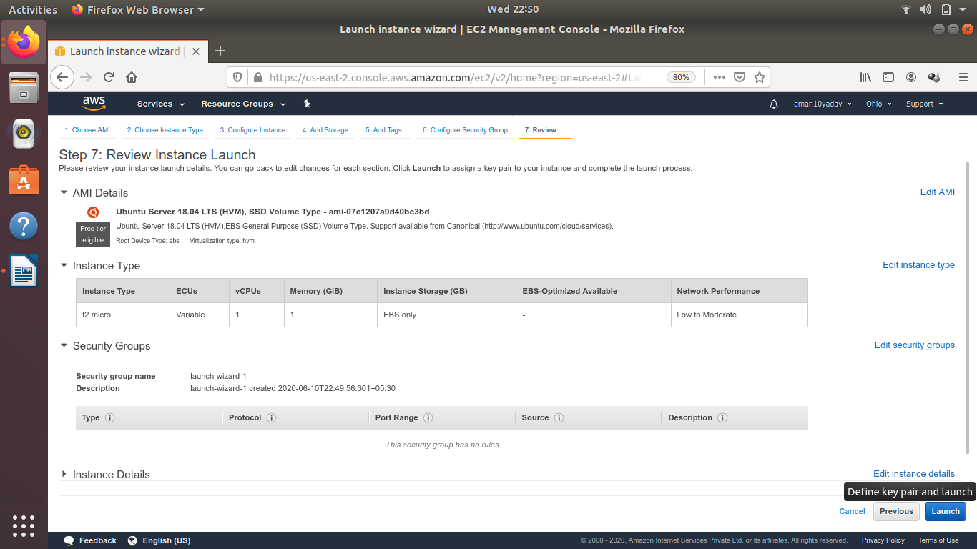

Step10 :- Select new pair key and then write a keypair name and download key pair or if you have existing then select option Choose an existing key pair and then select the key pair available.Then click on launch instance

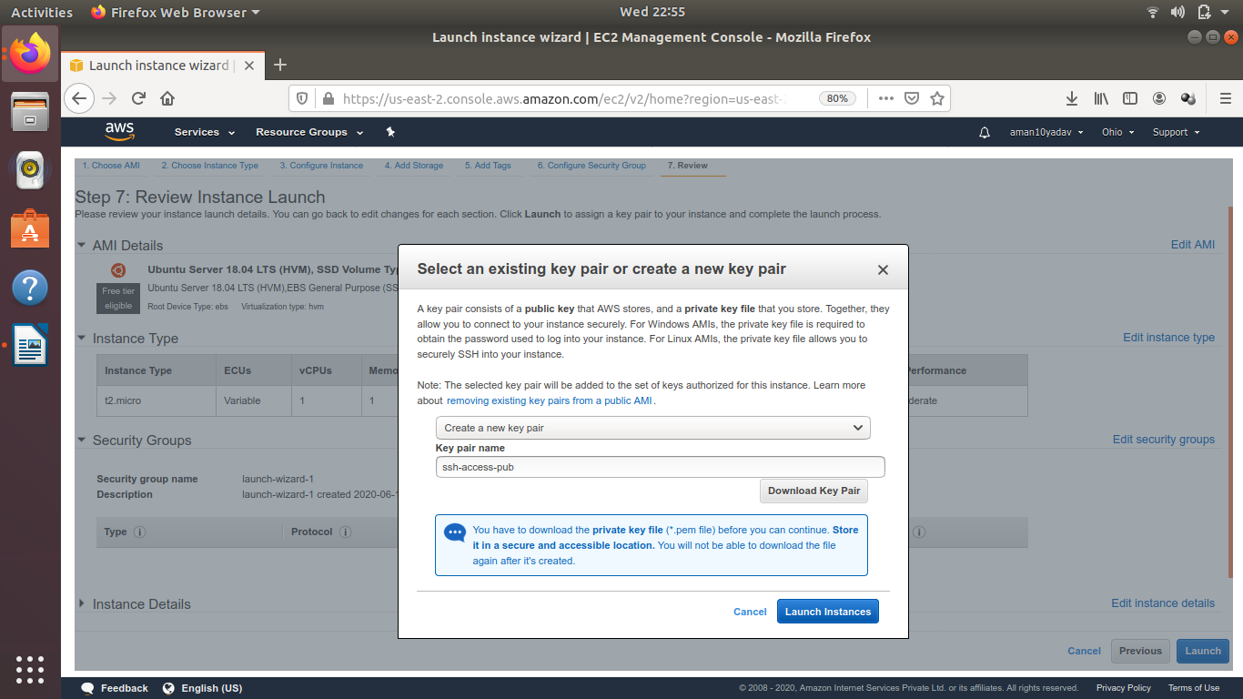

Step11 :- Now Launch Status window will appear as given below.After sucessfully completed the above steps.

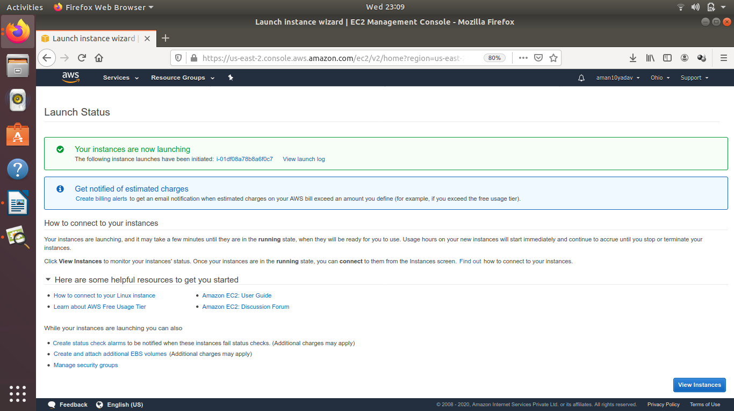

Step12 :- Now Select service > EC2 and then running instances and

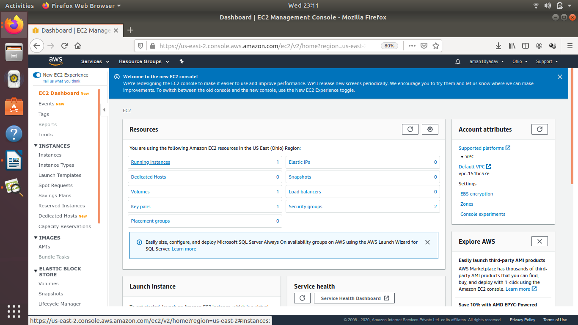

Step13 :- Finally all the instances made are shown now.

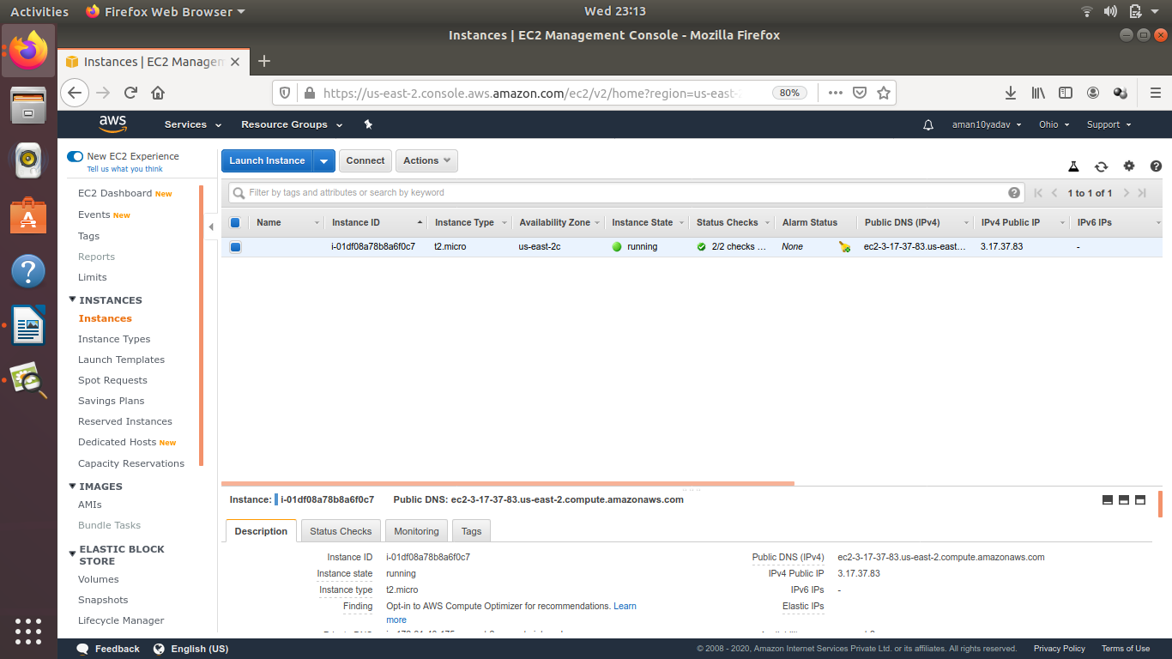

**Creating RDS in AWS**

Step1 :- In Homepage,click on service menu and then select RDS on Database section.



Step2 :- Click on Create Database on dashboard.

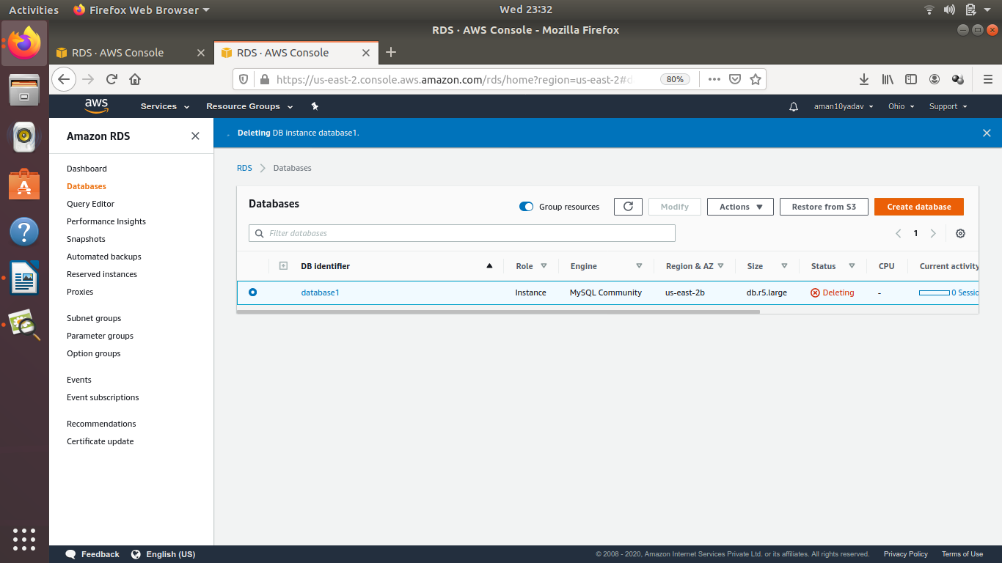

Step3 :- Choose standard Create in Database Creation method.

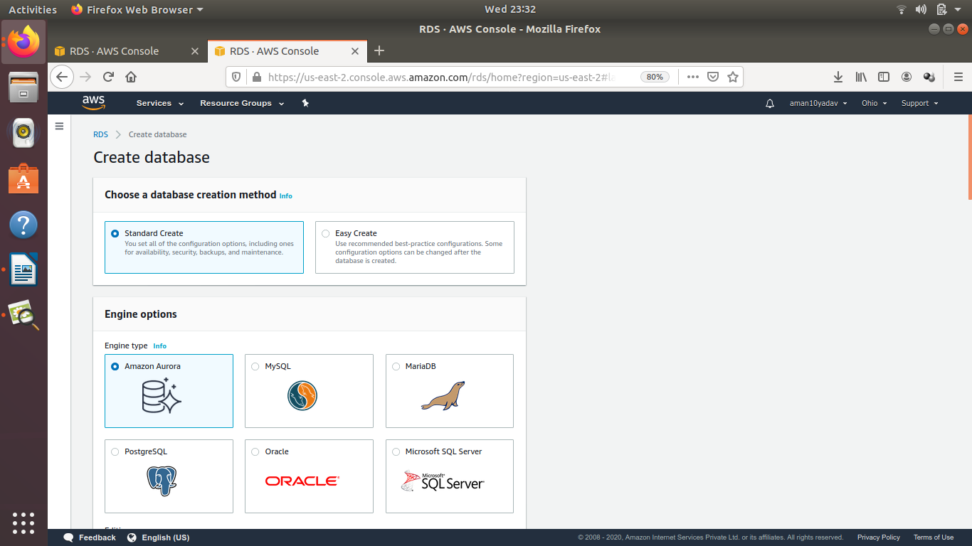

Step4 :- In Engine option,click on MySql or your own database.

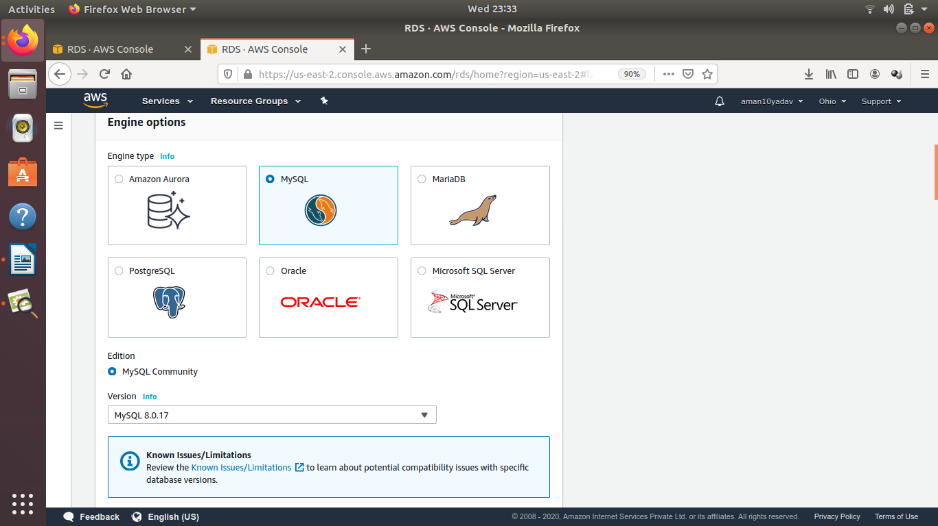

Step5 :- Select Template according to your requirement For example here it is selected free tier one.

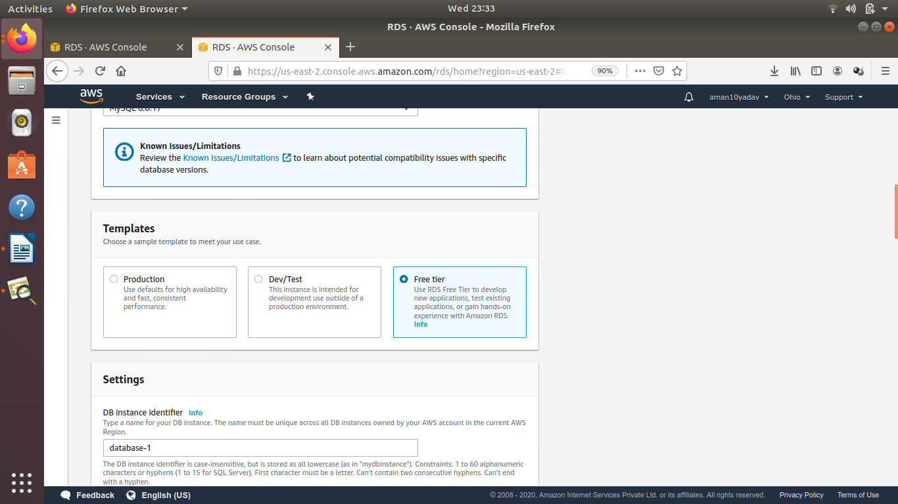

Step6 :- Provide Master Username and Password.

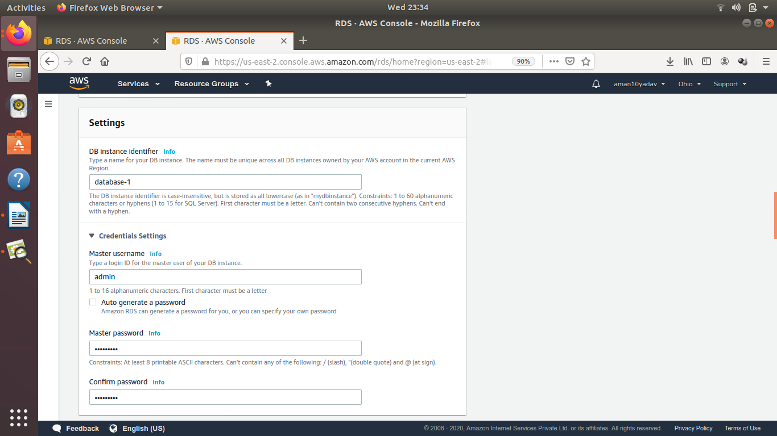

Step7 :- Edit storage as your requirement.

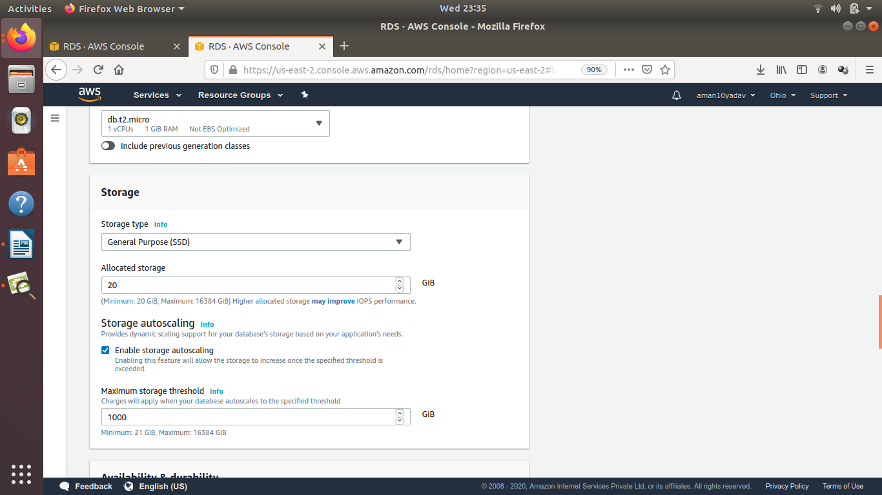

Step8 :- Now keep the database authentication as password authentication.

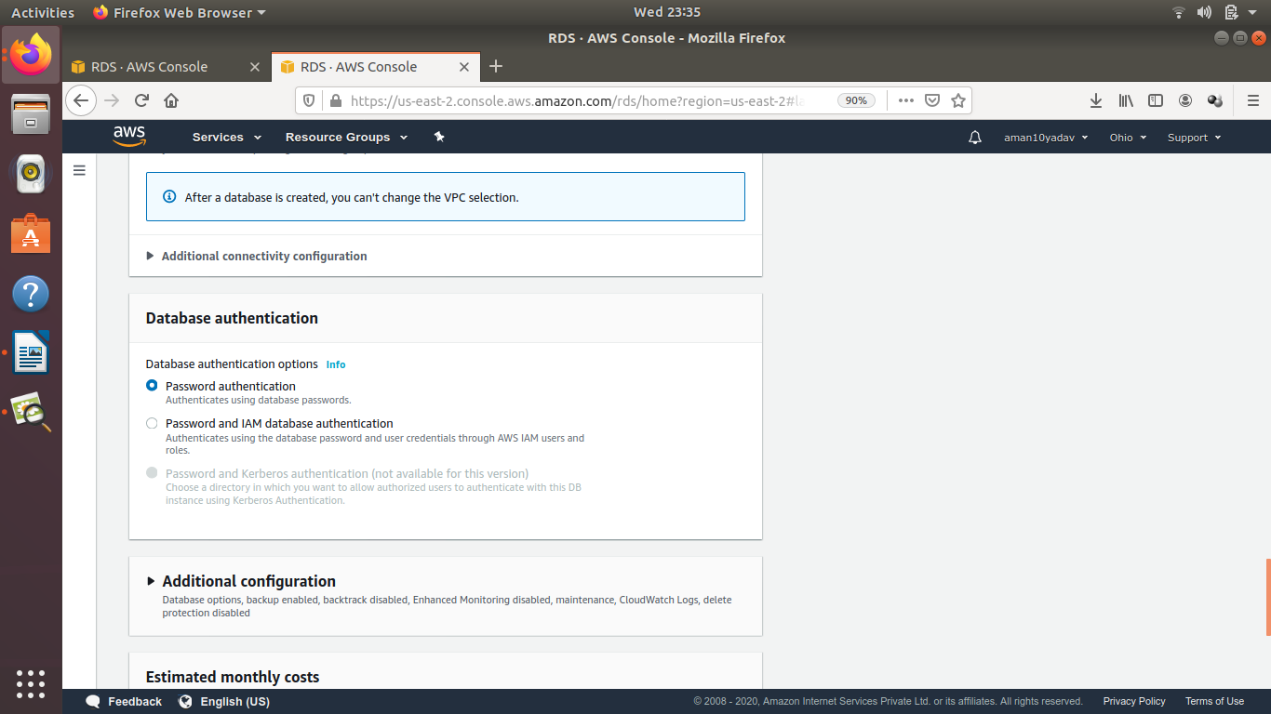

Step9 :- The estimated monthly cost will be shown and then click on Create Database.

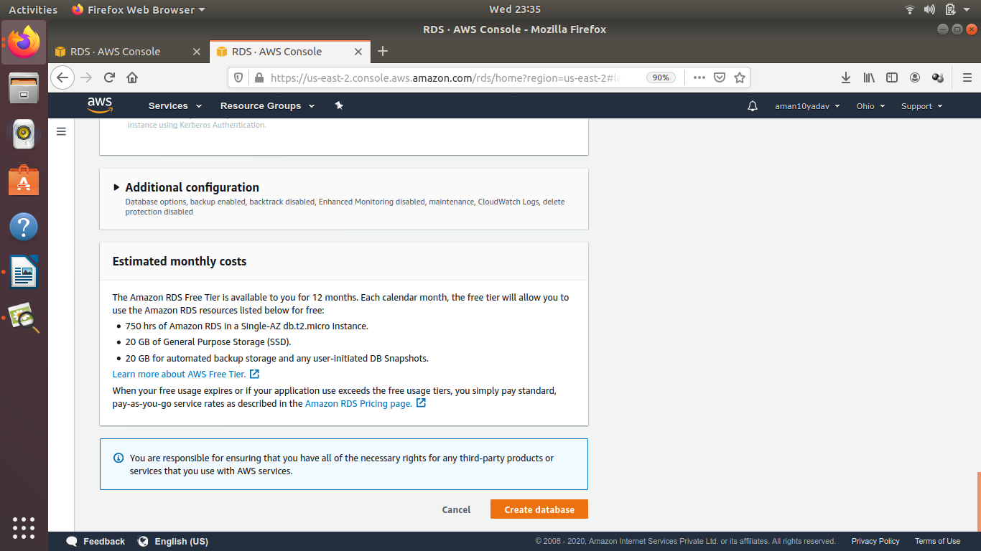

Step10 :- Finally after creating the database will be shown on dashboard as given below.

